## 6.Synchronous Counter

1. **Up counter.**

## Down counter.

1. **3 bit Synchronous up counter:**

The up counter counts from 0 to7 i.e.(000 to 111).for this we are using MS JK flip flop. In IC 74LS76, 2 MS J-K flip flops are present. The clock pulse is given at pin 1 & 6 of the 1st IC & pin 1 of 2nd IC. Next state decoder logic is designed with the help of state table.

## State table for synchronous up counter:

|  |  |  |  |  |  |  |  |  |  |  |  |
| --- | --- | --- | --- | --- | --- | --- | --- | --- | --- | --- | --- |
| **Present state** | | | **Next state** | | | **Flip flop 3** | | **Flip flop 2** | | **flip flop 1** | |
| **Q2** | **Q1** | **Q0** | **Q2** | **Q2** | **Q0** | **J2** | **K2** | **J1** | **K1** | **J0** | **K0** |
| 0 | 0 | 0 | 0 | 0 | 1 | 0 | x | 0 | X | 1 | x |
| 0 | 0 | 1 | 0 | 1 | 0 | 0 | x | 1 | X | x | 1 |
| 0 | 1 | 0 | 0 | 1 | 1 | 0 | x | x | 0 | 1 | x |
| 0 | 1 | 1 | 1 | 0 | 0 | 1 | x | x | 1 | x | 1 |
| 1 | 0 | 0 | 1 | 0 | 1 | x | 0 | 0 | X | 1 | X |
| 1 | 0 | 1 | 1 | 1 | 0 | x | 0 | 1 | X | x | 1 |
| 1 | 1 | 0 | 1 | 1 | 1 | x | 0 | x | 0 | 1 | X |
| 1 | 1 | 1 | 0 | 0 | 0 | x | 1 | x | 1 | x | 1 |

**K-Map :**

|  |  |  |  |  |
| --- | --- | --- | --- | --- |
| **Q1Q0**  **Q2** | **00** | **01** | **11** | **10** |
| **0** | 0 | 0 | 1 | 0 |
| **1** | X | X | X | X |

**J2 = Q1Q0**

|  |  |  |  |  |
| --- | --- | --- | --- | --- |
| **Q1Q0**  **Q2** | **00** | **01** | **11** | **10** |
| **0** | X | X | X | X |
| **1** | 0 | 0 | 1 | 0 |

**K2 = Q1Q0**

|  |  |  |  |  |
| --- | --- | --- | --- | --- |
| **Q1Q0**  **Q2** | **00** | **01** | **11** | **10** |
| **0** | 0 | 1 | X | X |
| **1** | 0 | 1 | X | X |

**J1 = Q0**

|  |  |  |  |  |
| --- | --- | --- | --- | --- |
| **Q1Q0**  **Q2** | **00** | **01** | **11** | **10** |
| **0** | X | X | 1 | 0 |
| **1** | X | X | 1 | 0 |

## K1 = Q0

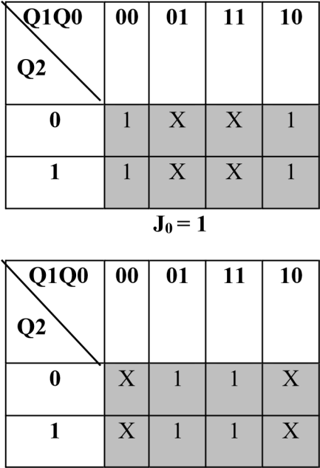

**K0 = 1**

## Logic Diagram:

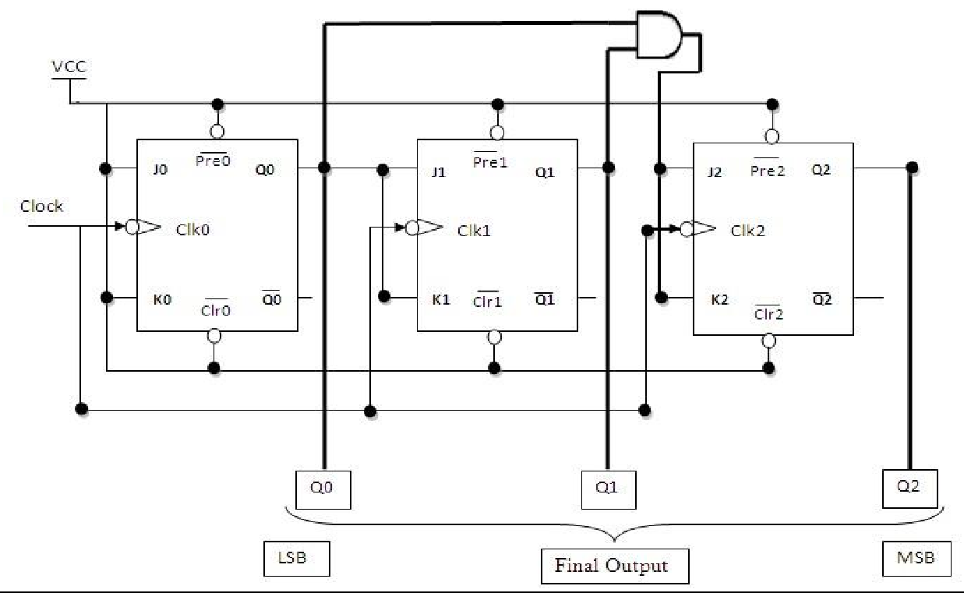

**Fig 1: 3 bit Synchronous up counter**

## 3 bit Synchronous down counter:

This is used to count from 7-0 i.e.(111-000).for this also 2 IC’s of 74LS76 are required & hence we use 3 MS JK flip flops. Here also clock is given to 1st & 6th pin of 1st IC & 1st pin of 2nd IC enabling to apply clock to all flip flop at a time. Next state decoder logic is designed with the help of state table.

**State table for synchronous down counter :**

|  |  |  |  |  |  |  |  |  |  |  |  |
| --- | --- | --- | --- | --- | --- | --- | --- | --- | --- | --- | --- |
| **Present state** | | | **Next state** | | | **Flip flop 3** | | **Flip flop 2** | | **Flip flop 1** | |
| **Q2** | **Q1** | **Q0** | **Q2** | **Q1** | **Q0** | **J2** | **K2** | **J1** | **K1** | **J0** | **K0** |
| **1** | **1** | **1** | **1** | **1** | **0** | **X** | **0** | **X** | **0** | **X** | **1** |
| **1** | **1** | **0** | **1** | **0** | **1** | **X** | **0** | **X** | **1** | **1** | **X** |
| **1** | **0** | **1** | **1** | **0** | **0** | **X** | **0** | **0** | **X** | **X** | **1** |
| **1** | **0** | **0** | **0** | **1** | **1** | **X** | **1** | **1** | **X** | **1** | **X** |
| **0** | **1** | **1** | **0** | **1** | **0** | **0** | **X** | **X** | **0** | **X** | **1** |
| **0** | **1** | **0** | **0** | **0** | **1** | **0** | **X** | **X** | **1** | **1** | **X** |
| **0** | **0** | **1** | **0** | **0** | **0** | **0** | **X** | **0** | **X** | **X** | **1** |
| **0** | **0** | **0** | **1** | **1** | **1** | **1** | **X** | **1** | **X** | **1** | **X** |

**K-Map :**

|  |  |  |  |  |
| --- | --- | --- | --- | --- |
| **Q1Q0**  **Q2** | **00** | **01** | **11** | **10** |
| **0** | 1 | 0 | 0 | 0 |
| **1** | X | X | X | X |

## J2 = Q1 Q0

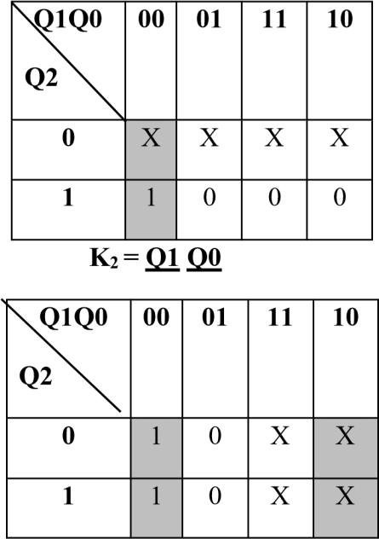

**J1 = Q0**

|  |  |  |  |  |
| --- | --- | --- | --- | --- |
| **Q1Q0**  **Q2** | **00** | **01** | **11** | **10** |
| **0** | X | X | 0 | 1 |
| **1** | X | X | 0 | 1 |

**K1 = Q0**

|  |  |  |  |  |
| --- | --- | --- | --- | --- |
| **Q1Q0**  **Q2** | **00** | **01** | **11** | **10** |
| **0** | 1 | X | X | 1 |
| **1** | 1 | X | X | 1 |

## J0 = 1

|  |  |  |  |  |
| --- | --- | --- | --- | --- |
| **Q1Q0**  **Q2** | **00** | **01** | **11** | **10** |
| **0** | X | 1 | 1 | X |
| **1** | X | 1 | 1 | X |

**K0 = 1**

## Logic Diagram :

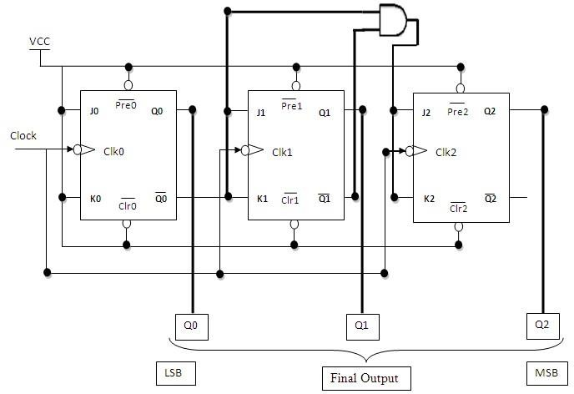

**Fig 2: 3 bit Synchronous down counter**

## Uses:

* 1. Specially used as the counting devices.
  2. Used in frequency divider circuit.
  3. Used in digital voltmeter.
  4. Used in counter type A to D converter.
  5. Used for time measurement..
  6. It helps in counting the no of product coming out from machinery where product is coming out at equal interval of time.

## Conclusion:

Up and down counters are successfully implemented, the counters are studied & o/p are checked. The state table is verified.

## PRACTICE ASSIGNMENTS / EXERCISE / MODIFICATIONS:

1. Design & implement 2 bit controlled synchronous counter.
2. Design & implement 4 bit controlled synchronous counter.
3. Design & implement truncated synchronous up or down counter.

## FAQ’s with answers:

1. What do you mean by Counter?

A Counter is a register capable of counting the no. of clock pulses arriving at its clock inputs. Count represents the no. of clock pulses arrived. A specified sequence of states appears as the counter output.

1. What are the types of Counters? Explain each.

There are two types of counters as Asynchronous Counter and Synchronous Counter. Asynchronous Counter: In this counter, the first flip-flop is clocked by the external clock pulse and then each successive flip-flop is clocked by the Q or Q’ o/p of the previous flip-flop. Hence in Asynchronous Counter flip-flops are not clocked simultaneously and hence called as Ripple Counter. Synchronous Counter: In this counter, the common clock input is connected to all the flip-flops simultaneously.

1. What do you mean by pre-settable counters?

A counter in which starting state is not zero can be designed by making use of the preset inputs of the flip flops. This is referred to as loading the counter asynchronously. This is referred to as pre-settable counter.

1. What are the applications of synchronous counters?

Digital clock

Frequency divider circuits Frequency counters

Used in analog to digital converters

1. What are the advantages of synchronous counters over asynchronous counters? Propagation delay time is reduced.

Can operate at a much higher frequency than the asynchronous counters.

1. Ring counter is an example of synchronous counters or asynchronous counter? Synchronous counter. Since all the flip flops are clocked simultaneously.
2. Twisted Ring (Johnson’s) counter is an example of synchronous counters or asynchronous counter?

Synchronous counter. Since all the flip flops are clocked simultaneously.

1. What is the difference between ring counter and twisted ring counter?

In ring counter pulses to be counted are applied to a counter , it goes from state to state and the output of the flip flop s in the counter is decoded to read the count. Here the uncomplimentary output (Q) of last flip flop is fed back as an input to first flip flop. Ring counters are referred as MOD ‘N’ counters.

But in Twisted ring counter the complimentary output (Q bar) of last flip flop is fed back as an input to first flip flop. Twisted Ring counters are referred as MOD ‘2N’ counters.

1. What are the applications of ring counters?

Ring counter outputs are sequential non-overlapping pulses which are useful for control state counters, Used in stepper motor, this requires pulses to rotate it from one position to the next. Used as divide by ‘N’ ((MOD ‘N’) counters.

1. What are the applications of ring counter twisted ring counters?

Used as divide by ‘2N’ ((MOD ‘2N’) counters. Used for control state counters.

Used for generation of multiphase clock.

1. List the Synchronous Counter ICs.

IC 74160 : Decade Up Counter

IC 74161 : 4 bit binary Up Counter

|  |  |
| --- | --- |
| IC 74162 | : Decade Up Counter |
| IC 74163 | : 4 bit binary Up Counter |
| IC 74168 | : Decade Up/Down Counter |
| IC 74169 | : 4 bit Binary Up/Down Counter |
| IC 74190 | : Decade Up/Down Counter |
| IC 74191 | : 4 bit Binary Up/Down Counter |
| IC 74192 | : Decade Up/Down Counter |
| IC 74193 | : 4 bit Binary Up/Down Counter |

